Greek Creation Myth Crossword Puzzle
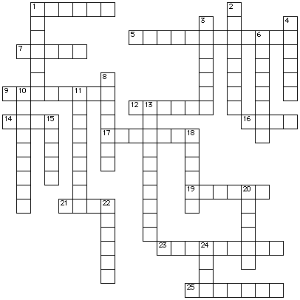
ACROSS
1. son of mother earth and the sky
5. impossible to reach
7. king of the underworld
9. what Zeus had to wear when he returned home
12. spirits of revenge that had a dog's head and bat's wings (Erinyes)
14. mother earth
16. Cronos' third daughter
17. forked spear with three points
19. lesser nature goddesses who cared for Zeus
21. son of Cronos who was saved by Rhea
23. goddess born from the foam of a drop of blood falling into the sea
25. name of the mountain that was the home of the gods
DOWN
1. one-eyed makers of Zeus' thunderbolts
2. king of the ocean
3. what Atlas had to hold up as punishment
4. what Pluto wore to become invisible
6. sent away
8. the second daughter of Cronos
10. existing only in the imagination - the kind of place Mount Olympus is believed to be
11. what Pluto's helmet made him
13. part of the universe ruled by Pluto
15. titan who was condemned to hold up the heavens as punishment
18. human-shaped giants who became the first gods and goddesses
20. Cronos' first daughter
22. a farm tool with a curved blade used for cutting grain
24. actual or authentic

